

Creating a Post in Tech Writers Tribe App

Quick Start Guide

Version 1.0

Copyright

Contents

**Overview 4**

**Creating a Post in Tech Writers Tribe App 4**

**Frequently Asked Questions 9**

**Best Practices 10**

# Overview

Creating a post allows you to share content, engage, and communicate with the community members. This quick start guide explains multiple methods for creating a post.

The illustration below outlines different ways of creating a post.

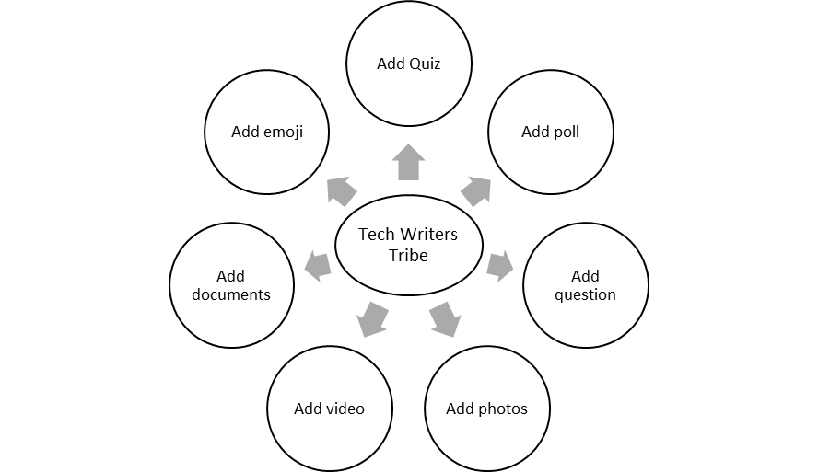

**Prerequisites**

* Stable internet connection
* Active account
* **Tech Writers Tribe** app

# Creating a Post in Tech Writers Tribe App

Creating a post allows you to share your knowledge, insights, and experiences with the **Tech Writers Tribe** community. It involves the following:

* Create a text-only post
* Add a quiz
* Add a poll
* Ask a question
* Share an image
* Share a video
* Share a document

**Create a Text-only Post**

Adding a text post helps you to convey your message instantly.

To create,

1. On your device, open the **Tech Writers Tribe** app.
2. On the home page, perform one of the following:

* In the left pane, select **Create a post**.
* In the middle pane, select the **Share something with the community** box.
* In the **Share something with the community** box in the middle pane, select the **+** icon.

The **Create Post** window appears.

1. In the **Create Post** window, enter your message.
2. (Optional) In the top-right pane, expand the **Add Tag** dropdown menu and select one of the following:

* API
* AI
* English
* Documentation tools

1. In the bottom pane, select **Post**.

**Note**: You can edit or delete your post as needed.

You have created a text post.

**Add a Quiz**

Adding a quiz enhances engagement, assesses knowledge, and promotes interactive learning within the community.

To add,

1. On your device, open the **Tech Writers Tribe** app.
2. On the home page, perform one of the following:

* In the left pane, select **Create a post**.
* In the middle pane, select the **Share something with the community** box.
* In the **Share something with the community** box in the middle pane, select the **+** icon.

The **Create Post** window appears.

1. In the **Create Post** window, select the **Add Quiz** icon.

The **Add a Quiz** page appears.

1. In the **Add a Quiz** page, enter the required details.

For example, as displayed below.

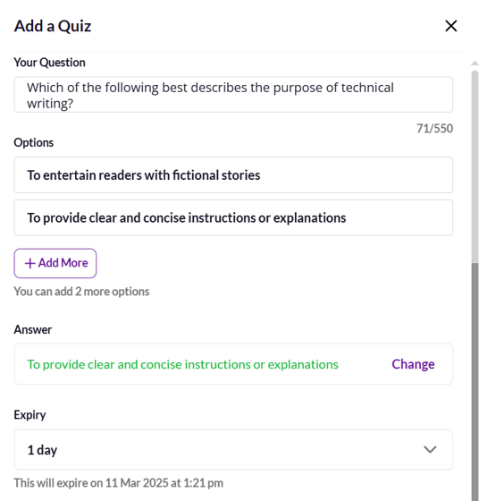

1. In the bottom pane, select **Add**.

You have added a quiz.

**Add a Poll**

Adding a poll helps in collecting opinions in a short time. It also encourages participation and interaction from your audience.

To add,

1. On your device, open the **Tech Writers Tribe** app.
2. On the home page, perform one of the following:

* In the left pane, select **Create a post**.
* In the middle pane, select the **Share something with the community** box.
* In the **Share something with the community** box in the middle pane, select the **+** icon.

The **Create Post** window appears.

1. In the **Create Post** window, select the **Add poll** icon.

The **Add a Poll** page appears.

1. In the **Add a Poll** page, enter the required details.

For example, as displayed below.

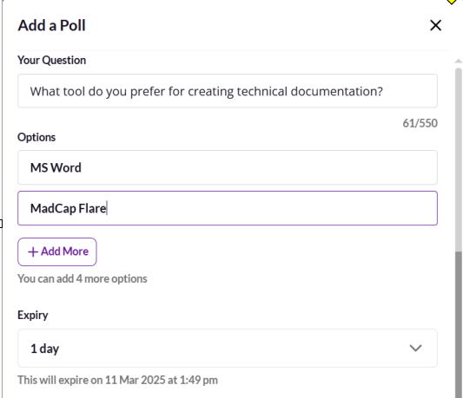

1. In the bottom pane, select **Add**.

You have added a poll.

**Add a Question**

Posting a question allows you to seek guidance and share knowledge. It also helps you to build a strong knowledge-sharing community.

To add,

1. On your device, open the **Tech Writers Tribe** app.
2. On the home page, perform one of the following:

* In the left pane, select **Create a post**.
* In the middle pane, select the **Share something with the community** box.
* In the **Share something with the community** box in the middle pane, select the **+** icon.

The **Create Post** window appears.

1. In the **Create Post** window, select the **Add question** icon.
2. In the **Add a Question** box, enter your question.
3. In the bottom pane, select **Add.**

You have added a question.

**Add an Image**

Sharing an image enhances communication, engagement, and clarity of your content. It also helps you to explain complex content visually.

To share,

1. On your device, open the **Tech Writers Tribe** app.
2. On the home page, perform one of the following:

* In the left pane, select **Create a post**.
* In the middle pane, select the **Share something with the community** box.
* In the **Share something with the community** box in the middle pane, select the **+** icon.

The **Create Post** window appears.

1. In the **Create Post** window, select the **Add photos** icon.

The **Add Photos** window opens.

1. In the **Add Photos** window, perform one of the following:

* Drag and drop method:

1. Open File Explorer or Finder on your device.
2. Locate and select your desired image.
3. Drag the image and drop it into the upload area.

* Browse and select method:

1. Select the **Drag and drop or click here to browse your files** box.

The File Explorer tool opens.

1. In the File Explorer tool, perform the following:
2. Locate and select your desired image.
3. In the bottom pane, select Open.

The image appears in the **Add Photos** Window.

**Note**: You can upload a maximum of 25 images per post.

5. In the bottom pane, select **Add**.

You have added an image.

**Share a Video**

Video sharing lets you visually demonstrate a process and engage your audience effectively. It also enhances understanding and interaction.

To share,

1. On your device, open the **Tech Writers Tribe** app.
2. On the home page, perform one of the following:

* In the left pane, select **Create a post**.
* In the middle pane, select the **Share something with the community** box.
* In the **Share something with the community** box in the middle pane, select the **+** icon.

The **Create Post** window appears.

1. In the **Create Post** window, select the **Add video** icon.

The **Add video** window appears.

1. In the **Add Video** window, perform one of the following:

* Drag and drop method:

1. Open File Explorer or Finder on your device.
2. Locate and select your desired video file.
3. Drag the file and drop it into the upload area.

* Browse and select Method:

1. Select the **Drag and drop or click here to browse your files** box.

The File Explorer tool opens.

1. In the File Explorer tool, perform the following:
2. Locate and select your desired video.
3. In the bottom pane, select Open.

The video appears in the **Add Video** window.

**Note**: You can upload a maximum of 1 video per post.

5. In the bottom pane, select **Add**.

You have shared a video.

**Share a Document**

Sharing a document allows you to access important information anytime. It allows you to provide structured information and maintain records efficiently.

To share,

1. On your device, open the **Tech Writers Tribe** app.
2. On the home page, perform one of the following:

* In the left pane, select **Create a post**.
* In the middle pane, select the **Share something with the community** box.
* In the **Share something with the community** box in the middle pane, select the **+** icon.

The **Create Post** window appears.

1. In the **Create Post** window, select the **Add documents** icon.

The **Add Documents** window appears.

1. In the **Add Documents** window, perform one of the following:

* Drag and drop method:

1. Open File Explorer or Finder on your device.
2. Locate and select your desired document.
3. Drag the document and drop it into the upload area.

* Browse and select method:

1. Select the **Drag and drop or click here to browse your files** box.

The File Explorer tool opens.

1. In the File Explorer tool, perform the following:
2. Locate and select your desired document.
3. In the bottom pane, Select Open.

The document appears in the **Add Documents** window.

5. In the bottom pane, select **Add**.

You have shared a document.

# Frequently Asked Questions

* How can I tag someone in my post?

Use @ followed by the username to tag a person. For example, @sudha.

* How do I pin a post?

Only admins can pin posts. If you want your post to be pinned, contact the admin.

* How do I report an inappropriate post?

To report,

1. Select the three-dot menu (⋮) on the post.
2. Select **Report Post** and select the reason for reporting.

The admin team will review the report.

* Can I recover a deleted post?

You cannot recover a post after you delete it.

# Best Practices

* Use relevant hashtags. For example, **#TechnicalWriting**, **#APIWriting**.
* Tag relevant members using **@username**.
* Encourage engagement by asking questions and replying to comments.
* Maintain a professional and respectful tone.